YPS Nova BSW 3 in 1 moving head
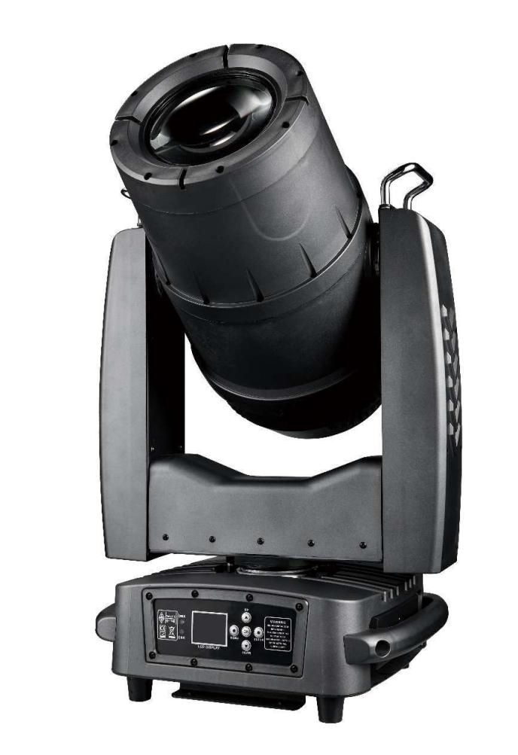
USER MANUAL

Catalogue
Chapter 1 Precautions and Installation 1
1. Maintenance and upkeep 1
2. Declaration 2
3. Product precautions 2
4. Installation of lighting fixtures 2
Chapter 2 Panel Operations 3
1. Overview 3
2. Operation 4
1. Use buttons or knobs to operate the lighting fixtures 4
2. Parameter numerical input 4
3. Set options to enable/disable 5
4. Subpages (Parameters) 5
5. Button anti misoperation operation 6
3. Function operation and parameter setting 6
1. Set DMX address code 6
2. Set the working mode of the lighting fixture 7
3. Panel display settings 8
4. Scene Mode 8
5. Set the working parameters of the lighting fixtures 9
6. Check the current status of the lighting fixtures 10
Chapter 3 Channel Description 12
1. Channel Table 12
Chapter 4 Common Malfunctions and Usage Precautions 15
1. Common fault handling 15
2. Precautions for use 16
3. Precautions for RDM Use 16

Chapter 1 Precautions and Installation
1.1 Declaration
Thank you for choosing the YPS NOVA! This product has good performance and complete packaging when it leaves the factory. For your safe and effective use of this product, please carefully and completely read this user manual before using it. This manual contains important information for installation and use. Please follow the requirements of the manual for installation and operation. At the same time, please keep this manual properly for use at any time. Our company does not assume any responsibility for any damage to lighting fixtures or other performance caused by individuals not following the instructions during installation, use, and maintenance.
This manual is subject to technical changes without prior notice.

1.2 Maintenance and upkeep
This lighting fixture is for outdoor use and should not be soaked in water. However, it can be used by sprinkling water around the perimeter of the fixture or during rainy weather.
Intermittent use can effectively extend the lifespan of this lighting fixture.
To achieve good ventilation and lighting effects, it is important to regularly clean the fan, fan mesh, and lens. Also it is imperative that you allow the unit to cool off prior to powering off the unit completely.
Do not wipe the lamp housing with organic solvents such as alcohol to avoid damage.

1.3 Product precautions
This lighting fixture is only for professional use.
Ensure that the power supply voltage matches the required power supply voltage of the equipment before operation.
Do not place this product in areas that are prone to looseness or vibration.
During use, if there are any abnormalities with the lighting fixtures, they should be stopped in a timely manner.
To ensure the service life of the product, it should not be placed in damp or leaking places, and should not be operated in environments with temperatures exceeding 60 degrees Celsius.
When using the light bulb, the voltage change of the power supply should not exceed ± 10%. If the voltage is too high, it will shorten the life of the light bulb, and if the voltage is too low, it will affect the light color of the light bulb.
After the power is cut off, it takes 20 minutes to fully cool the lighting fixture before it can be powered on again.
The rotating parts and adhesive accessories of the lighting fixtures must be regularly inspected, and any looseness or shaking should be promptly reinforced to prevent accidents.
Product Introduction
power: 650W
Drive power supply: 750W
Input voltage: 110v-240v 50—60Hz
Light source: Philips 480W/21R
Lens diameter: 148mm
Protection level: IP65
Beam angle: 4 ° -50 °
Vertical and horizontal: 540 ° rotation, 270 ° rotation
Color system: 12 color chips+atomization function
Pattern system: 12 fixed patterns+1 white light
Rotating pattern disc: 7 plug-in rotating patterns+1 white light
Channels: 20 channels
Installation and attention

Maintenance
- The lamp can be used outdoor in rain/water/snow,but can not be soaked in water
- Intermittently using will extend this item’s service life.
- Please clear the fan, fan net, and optical lens in order to keep good work state.
- Do not use the alcohol or any other organic solvent to wipe the shell.

Statement
The product has perfect performance and integrity packing. All users should be strictly complying with the warning and operating instructions as stated. Or we aren’t in charge of any result by misusing. Any damage resulting by misuse is not within the Company’s warranty. Any fault or problem caused by neglecting the manual is also not in the charge of dealers.
Note: All information is subject to change without prior notice.

Safety Precaution
- The product can not be directly soaked in water, and the use of lamps will not be affected in normal weather or rainy days, or in the periphery of the lamp body
- Always mount this unit in safe and stable matter.
- Install or dismantle should operate by professional engineer.
- Using lamp,the change rate of power voltage should be within±10%,If the voltage is too high,it will shorten the light’s life; If it’s not enough, will influence the effect.
- Please restart it 20 minutes later after turning off light , until full-cooling. Frequent switching will reduce the life span of lamps and bulbs; intermittent using will improve the life of bulbs and lamps.
- In order to make sure the product is used well, please read the Manual carefully.

Cable connection(DMX)
Use a cable conforming to specifications EIA RS-485: 2-pole twisted, shielded, 120Ohm characteristic impedance, 22-24 AWG, low capacity. Do not use microphone cable or other cable with characteristics differing from those specified. The end connections must be made using XLR type 3 or 5-pin male/female connectors. A terminating plug must be inserted into the last projector with a resistance of 120Ohm (minimum 1/4 W) between terminals 2 and 3.
IMPORTANT: The wires must not make contact with each other or with the metal casing of the connectors. The casing itself must be connected to the shield braid and to pin 1 of the connectors.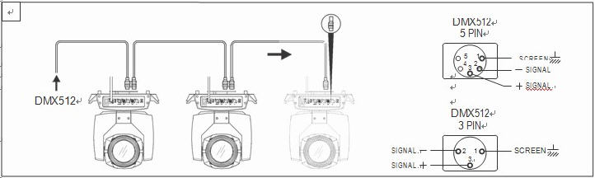
Figure 1 DMX Cable connection

Rigging (Optional)
This equipment can be positioned and fixed by clamp in every direction of the stage. Locking system makes it easy to fasten to the bracket.
Attention! Two clamps is needed to fix the equipment. Every clamp is locked by fastener of 1/4 kind. Fastener can only be locked clockwise.
Attention! Fasten a safety string to the additional hole of side aluminum piece. The secondary accessory can not hang on the delivery handle. Nip the equipment on bracket.
- Check if rigging clamp (not including the one inside) damaged or not? If stand ten times weight as the equipment. Make sure the architecture can stand ten times weight as all the equipments, clamps, wirings and other additional fixtures.
- Screws for clamping must be fixed firmly. Take one M12 screw (Grade 8.8 or higher) to clamp bracket, and then screw the nuts.
- Level the two hanging points at the bottom of clamp. Insert fastener to the bottom, lock the two levers by 1/4 rotating clockwise; then install another clamp.
- Install on safety string which stands at least ten times weight as equipment. Terminal of the accessory is designed for clamps.
- Make sure pan/tilt lock unlocked or not. Keep the distance more than 1M from equipment to flammable material or lighting source.
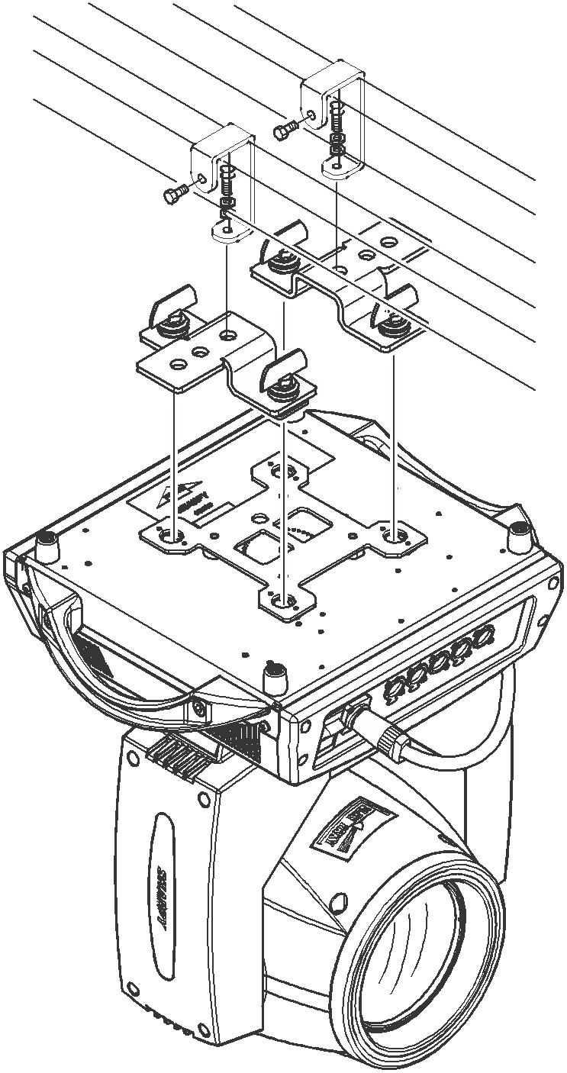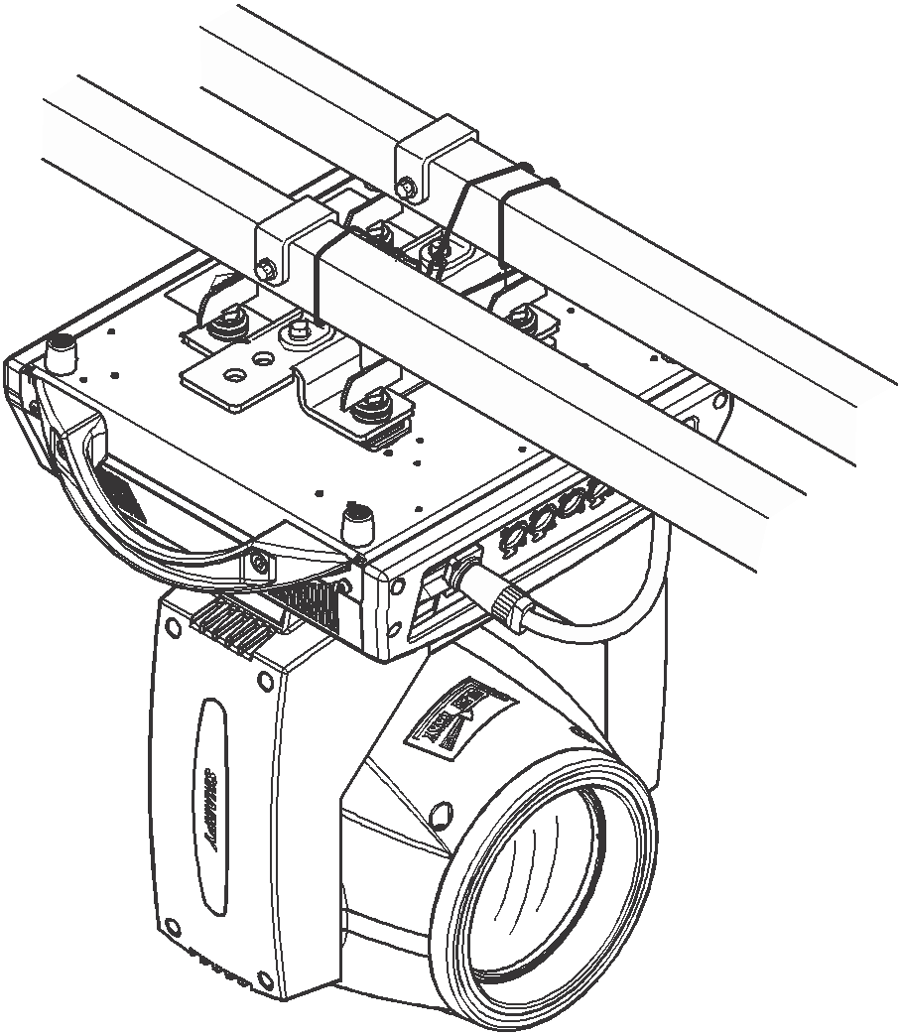
Figure 2 Installation

RDM Note
RDM is an extended version of DMX512-A protocol. It is a remote device management protocol. Traditional DMX512 protocol communication is one-way communication. The protocol is based on RS-485 bus. RS-485 is a time-sharing multi-point, half-duplex protocol. Only one port is allowed to output at the same time. So, when using RDM, we should pay attention to it. The following points:
- To use console or host device that supports RDM host protocol.
- Use bidirectional signal amplifier, traditional one-way signal amplifier is not suitable for RDM protocol, because the RMD protocol needs feedback data, the use of one-way amplifier will block the return of data, resulting in no search fixture;
- All fixture must be set to DMX mode to ensure only one host on the cable.
- A 120 ohm impedance matching resistor must be inserted between terminals 2 and 3 of the terminal plug. When the signal line is longer, reducing the signal reflection will make the differential signal more stable and beneficial to the quality of communication.
- When the fixture appears to accept DMX control, but can not been search by RDM host, first check the signal amplifier, and then check whether the signal line 2, 3 lines have bad contact.

Panel operation

Brief
The light panel diagram show as Figure 3, above area is Title for fixture description, below area show fixture real-time status, such as DMX cable status, lamp status, error or information(ps. when there are message hav’t been checked, echo ’ERR0. in status bar, otherwise echo ‘NOR’）.
Fixture TFT Displayer support touch, and right area is encoder or button, both of touch and coder button can operate fixture and setting.
Display & operation just like ‘Android operation system’， touch the item will set or modify setting.
RDM protocol is embed in fixture, user set DMX address via cable using the controller surpport RDM function. when fixture was search by controller, displayer will echo ‘RDM’ indicate this RDM is work.
Note: Prevent damage the touch or TFT displayer, Can not use sharp objects chick displayer.
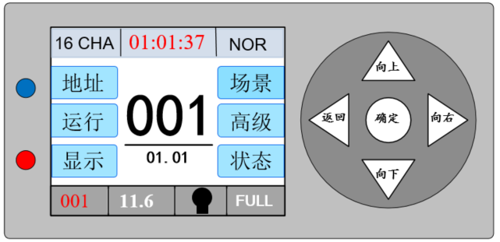
Figure 3 Panel diagram

Operation

Operate fixture with touch or encoder/button
  - The left area is the TFT display area and the touch area. Click the contents of the panel with your finger or blunt hardware to complete the parameter setting or check the status and other operations.
  - The right area is the auxiliary input. If you do not use the touch function that comes with TFT, you can use the auxiliary input to select the item to be set or viewed to complete the operation.

Parameter value setting
When the selected parameter item needs to enter a value, the window shown in Figure 4 will open.
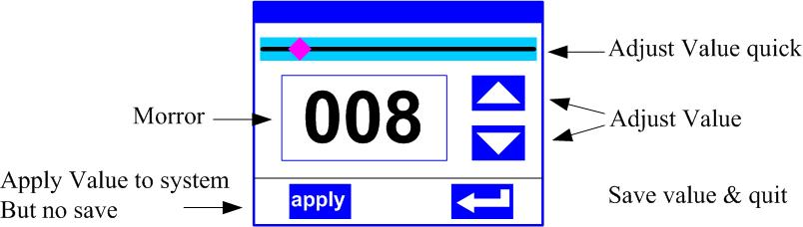
Figure 4 Dialog of value setting
- Modify value:You can directly pull the slider to quickly set the required value, or you can click the "up" or "down" button on the right to precisely set the required value or use the auxiliary input to set
- Applied value:When the data is set through the "up" or "down" button, and then press the "apply" application button in the lower left corner, the value is immediately sent to the fixture, but the value is not saved.
- Save Value:At any time, click the "OK" button in the lower right corner to save the current value to the internal memory, and the saved value will be applied to the fixture next time it is turned on.

Boolean parameter setting
- When the set parameter is a Boolean value (such as ON or OFF), you can directly click the corresponding item to switch the parameter value, and the modified parameter will be saved to the internal storage. Press the parameter option on the right, the corresponding option will be grayed out. When the hand is released, the corresponding parameters are changed and saved. If pressing the parameter option is not the parameter you want to change, you can move your finger to other places on the screen, and the corresponding parameter will not be changed.
- The determination of important Boolean parameters will be passed, and the confirmation window will be set, as shown in Figure 5 below. Chick ‘sure’ to confirm.
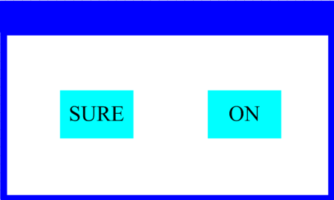
Figure 5 Dialog of confirm

Sub Menu(Parameter)
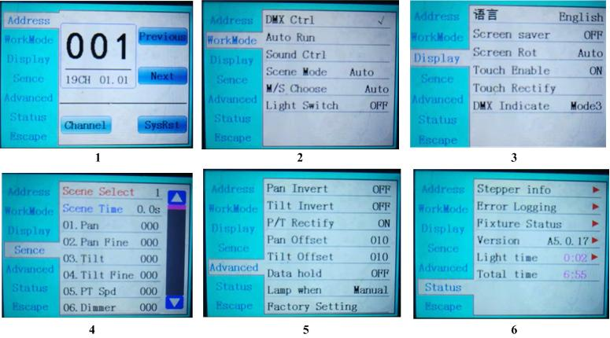
Figure 6 Parameter menu

Operation and parameter instruction
Enter the setting interface, as shown in Figure 6-1:
In the main interface, you can enter the corresponding parameter setting interface by selecting six buttons
In the parameter setting interface, you can press the blue option on the left to quickly switch to other setting interfaces

DMX Address setting
Through the page shown in Figure 6-1, the DMX address and channel mode of the fixture can be set.
The menu settings of the lamps optimize the address settings. The operations of several address codes are as follows:
- Select "Previous" or "Next", the fixture will automatically calculate the address code of the next or previous unit according to the current address code and channel data, which can be quickly set;
- Click the address code value to enter the value editing window, where you can set any valid address code, the fixture will automatically obtain the current channel number of the fixture, and automatically filter the unusable address code (512-current channel number)
- The lamps support RDM protocol, and the lamp address code can be set remotely through RDM.
Provide two buttons:
- Channel mode: you can choose different channel modes by cycle.
- Fixture reset: reset all motors. Set Light work mode

Fixture operating mode setting
Through the page shown in Figure 6-2, you can set the running mode of the fixture and control the fixture. The lamp supports four operating modes (DMX mode, auto run mode, sound control mode and scene mode). For detailed parameter value settings, please refer to the previous section. The specific parameter descriptions are shown in the following table:
operating mode
DMX Ctrl | DMX mode, receive DMX signal, RDM signal
Auto Run | Fixture run automatically according to built-in programs
Sound Ctrl | When the fixture detects a strong sound, the fixture automatically runs a scene according to the built-in program, otherwise it will stay the last scene
Scene Mode 01 | runs in a set scene, which supports most of the custom editing of 10 scenes.
Scene Mode 01 | 1~10 | outputs the specified scene
Scene Mode 01 | Auto | Automatically loops the output scene in the set scene time (non-zero) order, and the scene with time 0 automatically ignore
M/S Choose | It takes effect when not in DMX mode, select the data output mode, the lamp automatically detects the DMX state and automatically switches the output to prevent data conflict
M/S Choose | Master | The fixture operates as built-in, if there is no DMX signal, it will output data (synchronization), otherwise it will not output data
M/S Choose | Slave | The lamps operate as built-in and do not output data (other lamps are not synchronized)
M/S Choose | Auto | If there is no DMX signal, the fixture operates as built-in, otherwise, the fixture operates as DMX signal
Lamp switch | (Bulb source) A confirmation dialog box will pop up, select "SURE" to confirm the current operation, turn on or off the bulb, and the switching time interval is limited to 30 seconds
Lamp switch | Off | the current lamp output is off
Lamp switch | On | The current lamp output is turned on

The scene mode is suitable for a single or a small number fixture. You only need to output a fixed scene, or you need to run a simple program. You can edit it in the scene page without connecting to the console.

If the light source is a bulb, after turning off the bulb, please wait 10 minutes before turning on the bulb.
Panel Display Settings
The lamps support Chinese and English, upside-down display, etc., enter the corresponding parameter settings as shown in Figure 6-3, and the specific menu contents are shown in the following table:
DISPLAY SETTING
Language | display language settings
Language | English | English display
Language | Chinese | Chinese display
Screen saver | Set the display content or method of the screen after there is no operation on the screen for 30 seconds
Screen saver | OFF | Keep the last operation page and keep the screen on
Screen saver | Mode1 | screen off
Screen saver | Mode2 | The screen is black, and the address code of the current fixture is displayed in the lower left corner
Screen saver | Mode3 | Display trademark information, address code and operating mode
Screen Rot | Set the display direction of the screen.
Screen Rot | OFF | No reverse display
Screen Rot | ON | Reverse display
Screen Rot | AUTO | Automatically detect the direction of lamps and automatically switch direction.
DMX Indicate | Set the indication mode of DMX signal indicator.
DMX Indicate | Mode1 | When signal is bright, no signal is off.
DMX Indicate | Mode2 | When signal is off, no signal is bright.
DMX Indicate | Mode3 | When signal is flash, no signal is off.
Signal Bright | Set the brightness of the signal indicator
Signal Bright | 1~10 | 10
Screen Lihgt | Set the screen backlight for 10 seconds without operation
Screen Lihgt | 1~10 | 10
Touch switch | Choose whether to disable the touch function. When the screen touch is accidentally damaged, you can disable the touch function and use auxiliary input to set the fixture.
Touch | When the screen touch function work anomaly, you can enter the corrected page correction screen touch

For lamps that support touch operation, if there is a bad touch, you can enter the calibration page to recalibrate the touch accuracy of the touch screen. Under normal circumstances, please do not enter this page. If the touch is damaged, choose to disable the touch switch

Scene mode
Enter the page shown in Figure 6-4, and the fixture enters the scene editing mode. Under this page, the fixture does not receive DMX console data, and the edited data is reflected on the fixture immediately.
The content of the page depends on the currently selected channel, and the displayed channel content and order are consistent with the fixture channel table. Through this page, 10 scenes can be edited, as shown in the following table:
SCENE MODE
Scene Select | Select the current operation scenario.
Scene Select | 1~10 | The 10 scenes sets the format
Scene Time | Set the retention time of the current scene in automatic mode, the unit is 0.1 seconds
Scene Time | 0 | The current scene does not participate in automatic scene output
Scene Time | 1-255 | 0.1s—25.5s
1. PAN | 0-255 | Set the data of each channel, the display content and sequence are in one-to-one correspondence with the channel table of the fixture.
…… | 0-255
…… | 0-255
N. Function | 0-255

If you edit valid reset data in the reset channel in the scene, the fixture will reset, but after reset, the value of the corresponding reset channel will be automatically cleared to prevent multiple consecutive resets.

View this page, you can get the current channel list order of the fixture, please refer to the detailed channel description for specific channel data.
Set the working parameters
Enter the page shown in Figure 6-5, adjust the on-site parameters of the lamps, and facilitate the on-site installation of the lamps, etc.
ADVANCED SETTING
Pan Invert | Set the rotation direction of PAN
Pan Invert | OFF
Pan Invert | ON
Tilt Invert | Set the rotation direction of TILT
Tilt Invert | OFF
Tilt Invert | ON
P/T Rectify | Set whether the fixture detects XY out of step and corrects it
P/T Rectify | OFF | Uncorrected position after out of step
P/T Rectify | ON | Automatically correct position after out of step, and record out-of-step fault
Pan Offset | Set the position of the X-axis zero point of the fixture
Pan Offset | 4-150
Tilt Offset | Set the position of the Y-axis zero point of the fixture
Tilt Offset | 4-48
Data hold | Set the output state of the fixture when the fixture has no DMX signal
Data hold | OFF | No signal, so the motor and light source return to the position and state when reset is completed.
Data hold | ON | No signal, keep the last frame DMX data output.
Lamp mode | Set the way to first open the lamp after power up
Lamp mode | Power on | Turn on the lamp at power up and reset the lamp after 30 seconds.
Lamp mode | After reset | Reset the fixture after 3 seconds when power-on, and turn on the lamp after reset.
Lamp mode | Manual | After reset, manually turn on the lamp through the menu or console.
Factory Setting | Pop up the confirmation box, select "SURE", and return the lamp parameters to the factory settings.

When the power-on mode is selected, after the lamp is powered on, it will wait for the bulb for 30 seconds to fully start the bulb. After the internal voltage is stable enough, the reset procedure will be started. If the on-site power consumption is stable, the power-on bulb mode is recommended. .

When the lamp cannot correct the position, please first check whether the "Optocoupler Correction" is turned off.

When the signal is unplugged, if the position of the fixture is not output as expected, please check the "Data Hold" setting first.

When setting the XY offset, after completing the setting, please control the XY with the maximum stroke first, to check that after the setting, the XY will not hit the positioning rod or the housing.

Status and information
Enter the page shown in Figure 6-6, you can view the information and real-time status of the lamps to know the use status of the lamps. If the lamps need after-sales, please provide the status information displayed on this page as a basis for judgment, as shown in the following table:
STATUS INFORMATION
Stepper info | Display information status of all motors and signals in fixture.
Stepper info | Hall | If it is not displayed, it means that the motor has no Hall calibration, 0 means that the motor leaves the calibration position, and 1 means that the motor is at the calibration position.
Stepper info | Status | Display motor reset status
Stepper info | PAN | Display real-time position value of PAN optocoupler feedback
Stepper info | TILT | Display real-time position value of TILT optocoupler feedback
Stepper info | PAN OP | Displays the PAN TILT optocoupler two signal level state, binary
Error Logging | Display the last 8 fault records when the lamp is reset and running. The fault records will not be saved after the power is turned off, and the current power-on cycle will be valid.
Error Logging | Error Logging | Total number of failures detected after power on
Error Logging | 12：03 | The time of power failure when the fault occurs is in minutes.
Error Logging | Hall error | The effective hall signal is not detected when the motor is reset
Error Logging | Hall short | When the motor is reset, the hall signal of the motor is always effective
Error Logging | Opti error | No effective optocoupler signal is detected when the motor is reset.
Error Logging | Lose stop | The corresponding motor is out of step during its operation.
Error Logging | Hit | Striking the positioning rod when the motor is reset
Error Logging | Lamp error | Lamp explosion accident
Error Logging | NTC error | The temperature sensor signal is abnormal
Error Logging | Fan error | The main fan is not working properly.
Fixture status | Displays the critical state data of the current fixture for reference.
Fixture status | Communication prec | 0%～100%, Communication quality of internal data link of lamps and lanterns
Fixture status | Error cnt | The number of erroneous frames was detected after power on, and the total number of erroneous frames was detected.
Fixture status | Light Temperature | Show the temperature of the current light source, "---" means no detection.
Fixture status | Panel Temperatrue | Displays the temperature of the current display panel or the ambient temperature.
Fixture status | Sensor1 Temperatrue | Display the ambient temperature of the motherboard temperature or the motherboard installation position.
Version | Display the information and version of the current fixtrue, important reference for after sales maintenance.
Version | Device | The name of the fixture is the same as the equipment information of RDM.
Version | Model | The type of fixture is the same as the model information of RDM.
Version | Panel | Firmware version and serial number of display panel
Version | Main Board | Firmware version and serial number of mother board 1
Light time | Record the total cumulative time of light source opening, unit minute, user manual cleaning, as a reference for regular maintenance of light source time
Total time | The total accumulated time for recording the opening of fixture is not allowed to be removed.

Chapter 2 Channel Description

Channel table
 | LIST-1 | LIST-2 | NAME | VALUE | BRIEF
 | [ CH1 ] | [ CH1 ] | Pan | 0-255 | 0-540(degree)
 | [ CH2 ] | [ CH2 ] | Pan Fine | 0-255 | 0-2(degree)
 | [ CH3 ] | [ CH3 ] | Tilt | 0-255 | 0-270(degree)
 | [ CH4 ] | [ CH4 ] | Tilt Fine | 0-255 | 0-1(degree)
 | [ CH5 ] |  | PT Spd | 0-255 | Fast to slow
 | [ CH6 ] | [ CH5 ] | Dimmer | 0-255 | 0%～100% dimmer
 | [ CH7 ] | [ CH6 ] | Strobe
 |  |  |  | 0-3 | Dark
 |  |  |  | 4-103 | Pluse strobe slow to fast
 |  |  |  | 104-107 | Open
 |  |  |  | 108-207 | Fade strobe slow to fast
 |  |  |  | 208-212 | Open
 |  |  |  | 213-251 | Rand strobe slow to fast
 |  |  |  | 252-255 | Open
 | [ CH8 ] | [ CH7 ] | Colour
 |  |  |  | 0-9 | White
 |  |  |  | 10-14 | White+colour1
 |  |  |  | 15-19 | Colour1
 |  |  |  | 20-24 | Colour1+Colour2
 |  |  |  | 25-29 | Colour2
 |  |  |  | 30-34 | Colour2+Colour3
 |  |  |  | 35-39 | Colour3
 |  |  |  | 40-44 | Colour3+Colour4
 |  |  |  | 45-49 | Colour4
 |  |  |  | 50-54 | Colour4+Colour5
 |  |  |  | 55-59 | Colour5
 |  |  |  | 60-64 | Colour5+Colour6
 |  |  |  | 65-69 | Colour6
 |  |  |  | 70-74 | Colour6+Colour7
 |  |  |  | 75-79 | Colour7
 |  |  |  | 80-84 | Colour7+Colour8
 |  |  |  | 85-89 | Colour8
 |  |  |  | 90-94 | Colour8+Colour9
 |  |  |  | 95-99 | Colour9
 |  |  |  | 100-104 | Colour9+Colour10
 |  |  |  | 105-109 | Colour10
 |  |  |  | 110-114 | Colour10+Colour11
 |  |  |  | 115-119 | Colour11
 |  |  |  | 120-124 | Colour11+Colour12
 |  |  |  | 125-129 | Colour12
 |  |  |  | 130-134 | Colour12+Colour13
 |  |  |  | 135-193 | Rotate forward (fast to slow)
 |  |  |  | 194-196 | Stop
 |  |  |  | 197-255 | Rotate reverse (slow to fast)
 | [ CH9 ] | [ CH8 ] | Gobo
 |  |  |  | 0-4 | White
 |  |  |  | 5-9 | Gobo1
 |  |  |  | 10-14 | Gobo2
 |  |  |  | 15-19 | Gobo3
 |  |  |  | 20-24 | Gobo4
 |  |  |  | 25-29 | Gobo5
 |  |  |  | 30-34 | Gobo6
 |  |  |  | 35-39 | Gobo7
 |  |  |  | 40-44 | Gobo8
 |  |  |  | 45-49 | Gobo9
 |  |  |  | 50-54 | Gobo10
 |  |  |  | 55-59 | Gobo11
 |  |  |  | 60-64 | Gobo12
 |  |  |  | 65-69 | Shake slow to fast Gobo1
 |  |  |  | 70-74 | Shake slow to fast Gobo2
 |  |  |  | 75-79 | Shake slow to fast Gobo3
 |  |  |  | 80-84 | Shake slow to fast Gobo4
 |  |  |  | 85-89 | Shake slow to fast Gobo5
 |  |  |  | 90-94 | Shake slow to fast Gobo6
 |  |  |  | 95-99 | Shake slow to fast Gobo7
 |  |  |  | 100-104 | Shake slow to fast Gobo8
 |  |  |  | 105-109 | Shake slow to fast Gobo9
 |  |  |  | 110-114 | Shake slow to fast Gobo10
 |  |  |  | 115-119 | Shake slow to fast Gobo11
 |  |  |  | 120-127 | White
 |  |  |  | 128-190 | Rotate reverse (fast to slow)
 |  |  |  | 191-192 | Stop
 |  |  |  | 193-255 | Rotate forward (slow to fast)
 | [ CH10 ] | [ CH9 ] | Rot Gobo
 |  |  |  | 0-9 | White
 |  |  |  | 10-19 | Gobo1
 |  |  |  | 20-29 | Gobo2
 |  |  |  | 30-39 | Gobo3
 |  |  |  | 40-49 | Gobo4
 |  |  |  | 50-59 | Gobo5
 |  |  |  | 60-69 | Gobo6
 |  |  |  | 70-79 | Gobo7
 |  |  |  | 80-89 | Shake slow to fast Gobo1
 |  |  |  | 90-99 | Shake slow to fast Gobo2
 |  |  |  | 100-109 | Shake slow to fast Gobo3
 |  |  |  | 110-119 | Shake slow to fast Gobo4
 |  |  |  | 120-129 | Shake slow to fast Gobo5
 |  |  |  | 130-139 | Shake slow to fast Gobo6
 |  |  |  | 140-149 | Shake slow to fast Gobo7
 |  |  |  | 150-200 | Rotate forward (fast to slow)
 |  |  |  | 201-205 | Stop
 |  |  |  | 206-255 | Rotate reverse (slow to fast)
 | [ CH11 ] | [ CH10 ] | Gobo.Rot
 |  |  |  | 0-127 | 0-360(degree)
 |  |  |  | 128-190 | Rotate reverse (fast to slow)
 |  |  |  | 191-192 | Stop
 |  |  |  | 193-255 | Rotate forward (slow to fast)
 | [ CH12 ] | [ CH11 ] | Gobo.R F | 0-255
 | [ CH13 ] | [ CH12 ] | Prism1
 |  |  |  | 0-127 | None
 |  |  |  | 128-255 | Inert prism1
 | [ CH14 ] | [ CH13 ] | Prism2
 |  |  |  | 0-127 | None
 |  |  |  | 128-255 | Insert prism2
 | [ CH15 ] | [ CH14 ] | Prism1.R
 |  |  |  | 0-127 | 0-360(degree)
 |  |  |  | 128-187 | Rotate forward (fast to slow)
 |  |  |  | 188-195 | Stop
 |  |  |  | 196-255 | Rotate reverse (slow to fast)
 | [ CH16 ] | [ CH15 ] | Frost
 |  |  |  | 0-127 | None
 |  |  |  | 128-255 | Insert frost
 | [ CH17 ] | [ CH16 ] | Zoom | 0-255 | Large to small
 | [ CH18 ] | [ CH17 ] | Focus | 0-255 | Far to near
 | [ CH19 ] |  | Focus F | 0-255
 | [ CH20 ] | [ CH18 ] | Reset
 |  |  |  | 0-99 | None
 |  |  |  | 100-105 | Turn off lamp over 3 second
 |  |  |  | 106-199 | None
 |  |  |  | 200-205 | Turn on over 3 second
 |  |  |  | 206-209 | None
 |  |  |  | 210-215 | Reset XY motor over 3 second
 |  |  |  | 216-219 | None

Chapter 3 Common Malfunctions and Precautions for Use

1. Common fault handling

The lamp contains professional components such as microcomputer circuit boards and high-voltage power supplies. For your safety and product lifespan, non professionals are not allowed to disassemble the lamp and related accessories without authorization.

1. The light bulb does not light up (except for LED light sources)

Possible reasons: The bulb has not completely cooled down, or the bulb has reached its lifespan. The following measures should be taken:

Due to abnormal operation, the bulb has not been completely cooled down. The lamp body should be allowed to cool for more than 10 minutes to fully restore its internal normal state, and then the power should be restarted;

Check if the light bulb has reached its service life and replace it with a new one;

Check if there is any leakage, detachment or poor contact between the bulb and the lighting circuit;

Replace the lamp with a new one.

2. The beam appears dim

Possible reasons: The light bulb has been used for a long time or the light path is not clean. The following measures should be taken:

Check if the light bulb has reached its service life and replace it with a new one;

Check whether the optical components or light bulbs are clean, whether there is dust accumulation on the optical components such as light bulbs, and regularly clean and maintain the light bulbs and various components inside the lamp.

3. Pattern projection blurred

Check if the electronic focusing channel value is appropriate for the current projection distance.

4. The lighting fixtures work intermittently

Possible cause: The internal circuit has entered a protected state. The following measures should be taken:

Check if the fan is running normally or if it has become dirty, causing an increase in the internal temperature of the lighting fixture;

Check if the internal temperature control switch is in the closed state;

Check if the light bulb has reached its service life and replace it with a new one.

5. After the lamp is reset normally, it does not accept control from the console

Possible reasons: Signal line malfunction or abnormal lighting parameter settings. The following are the solutions:

Check the starting address code and the connection status of the DMX signal cable (whether the signal cable is intact and whether the connector is loose);

Add a signal amplifier and a 120 ohm terminal resistor;

6. The lighting fixture cannot be started

Possible cause: Poor power supply circuit. The following measures should be taken:

Check if the fuse on the power input socket is blown and replace it;

Poor line contact caused by vibration during long-distance transportation of lighting fixtures

Check the input power supply, computer board, and other plug-in components.
- Precautions for use
- Check whether the local power supply meets the rated voltage requirements of the product, and whether the leakage protector, overcurrent protector, etc. meet the load requirements carried;
- Do not use power cords with damaged insulation layers, and do not overlap the power cords with other wires;
- The lighting fixture adopts strong wind cooling, which is prone to dust accumulation. It must be cleaned once a month, especially the heat dissipation vent, otherwise it will be blocked by dust accumulation, resulting in poor heat dissipation and abnormal lighting fixtures.
- When installing lighting fixtures, the fixing screws must be tightened, and safety ropes must be added and checked regularly;
- When installing and positioning the lamp, any point on the surface of the lamp should maintain a minimum distance of 10 meters from any flammable or explosive material, and a distance of 2.5 meters from the illuminated object. Please do not directly install the lamp on the surface of flammable materials;
- It is recommended that the continuous working time of the lamp should not exceed 10 hours, and the interval between continuous starting of the lamp should not be less than 10 minutes, otherwise it may not be triggered properly due to bulb overheating protection;
- The closing time of the switch valve should not exceed 5 minutes. If it is necessary to turn off the light for a long time, the control panel (lamp control channel) should be used to turn off the lamp;
- In order to ensure that multiple lighting fixtures better comply with the scene effect, the lighting fixtures should not be constantly in an unfinished state, that is, starting the next scene action. It is best not to exceed 3 minutes in this state to ensure that multiple lighting fixtures can run synchronously;
- During use, if there are any abnormalities in the lighting fixtures, they should be stopped in a timely manner to prevent the occurrence of other malfunctions.
- 29. Precautions for using RDM
- RDM is an extended version of the DMX512-A protocol, which is a remote device management protocol. Traditional DMX512 protocol communication is one-way, and the protocol is based on the RS-485 bus. RS-485 is a time-sharing multi-point, half duplex protocol that allows only one port to be the host output at a time. Therefore, when using RDM, the following points should be noted:
- Use a console or host device that supports RDM protocol host;
- To use a bidirectional signal amplifier, traditional unidirectional signal amplifiers are not suitable for RDM protocol because RMD protocol requires feedback data. Using a unidirectional amplifier will block the returned data, resulting in the inability to search for lighting fixtures;
- All lighting fixtures must be set to DMX mode to ensure that there is only one host on the signal line;
- A 120ohm impedance matching resistor must be inserted between terminals 2 and 3 of the terminal plug. When the signal line is relatively long, reducing signal reflection will make differential signals more stable and beneficial for communication quality;
- When a light fixture is controlled by DMX but cannot be searched by RDM, first check the signal amplifier, and then check if there is a poor contact between the 2 and 3 wires of the signal line.
Lamp parameters:
Light source model: Philips 480W/21R
Rated lifespan: 2000 hours
Color temperature: 6500K
Focusing: Using high-precision glass lens and electronic linear high-definition focusing
Zoom: 4 °~50 ° linear high-speed zoom, uniform and consistent light spot in any range
Color rendering index: Ra≥70, High color rendering mode with Ra ≥ 90, in addition, high color rendering light sources with Ra ≥ 95 can be selected
Pattern system
Rotating pattern: One rotating pattern disc has 7 optional pattern pieces, with variable speed shaking and bidirectional rotation. The pattern rotation has a 16 bit precision fine adjustment
Fixed pattern: One fixed pattern disc has 12 optional pattern pieces, with variable speed shaking and bidirectional rotation
Color system
Color palette: One color palette has 12 color palettes, which can achieve bidirectional rainbow effect, half color and linear adjustment
Physical/Installation Characteristics
Weight: 28Kg
Protection level: IP65
Input voltage: AC 100V -240V 50/60Hz
Signal interface: 3-core input/output
Control channel: 20 channels
Transmission Protocol: DMX512 RDM
Display mode: LCD display screen
Horizontal/Vertical Effect: Horizontal scanning angle of 540 °, vertical scanning angle of 270 °, automatic return correction and 16 bit precision fine-tuning function
Aperture: 5%～100% linear adjustment, with multiple macro function effects
Strobe: Fast flicker at 1—25Hz per second, with pulse flicker and synchronous asynchronous flicker effects
Dimming: 0%～100% electronic linear dimming
Prism: 1 3 prism, 1 8 prism with bi-directional variable speed rotation
Atomization: 0%～100% linear softening adjustment, synchronous zoom to generate softening effect
Display feature: automatic inversion
Automatic energy-saving: an intelligent tracking energy-saving system with timely reduction of light source power.
Sleep function: When the light fixture disconnects the signal, it automatically enters sleep mode, making the light fixture more stable and safe.
Communication design: DMX wired/wireless transmission, convenient and fast software upgrade through DMX data cable.
Heat dissipation design: Adopting a copper tube+fan heat dissipation structure and temperature intelligent monitoring technology, the heat dissipation system is automatically adjusted to effectively control the temperature of the lighting fixtures. Lamp size: 73.7 * 30.6 * 43cm Net weight: 28kg

